Class of 2020 Christmas Fundraiser
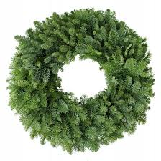  $15 | 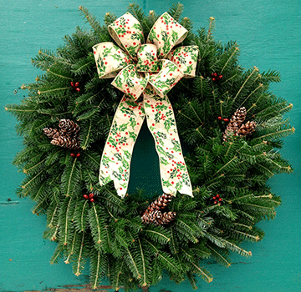  $20 | 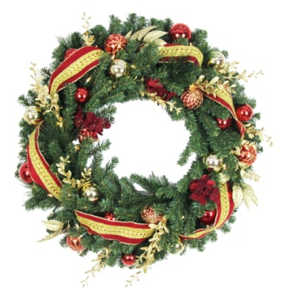  $25 | 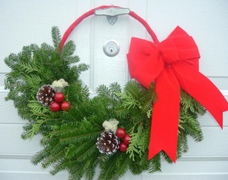  $12
Plain wreath | Traditional wreath | Deluxe wreath | Basket wreath
Approx. 18" across.  No decorations | Approx. 18" across  Pinecones and bow | Approx. 18" across  Fully Decorated. | Approx. 14" across  Pinecones and bow
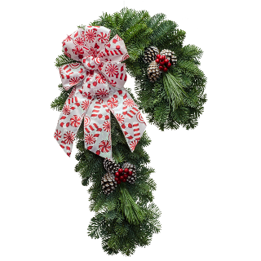
$18  $18 | $12 | 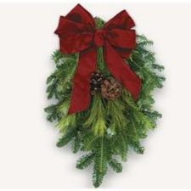  2  for  $16 | 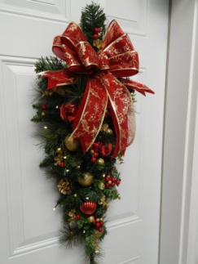  $20
Candy Cane Wreath | Corner Swag | Small Swag | Deluxe Swag
Approx. 25" long.  Pinecones and bow | Approx. 12" each side.  Pinecones and bow | Approx. 14" long  Pinecones and bow | Approx. 25" long  Fully Decorated.
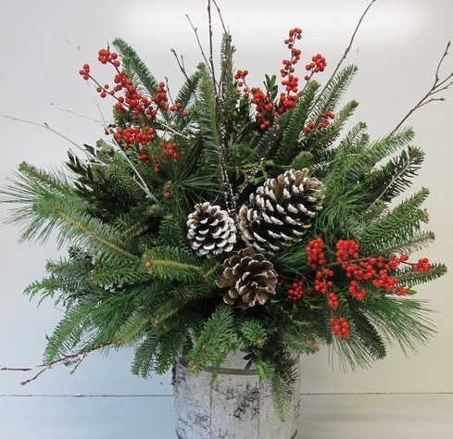  $20  $18 | 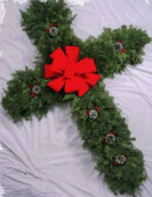  $20 | $25 | $18
Indoor Centerpiece | Cross wreath | Mantel/Table Runner | Window Sill Swag
Small approx. 15" Large approx. 18"  Fully Decorated. | Approx. 26" long.  Great for churches and graveside.  Pinecones and bow | Approx. 4 to 5 foot long. Made on rope so that it is flexible.  Fully Decorated. | Approx. 26" across. Nice for windows or doors.  Straight - Not flexible.  Pinecones and bow
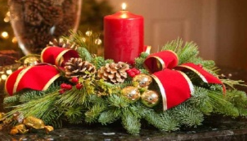  $18 | Each item is made with fresh local evergreen tips - fir, pine or cedar - as well as pine cones, and red branches (depending on the item).  All bows are handmade using varied ribbons and /or deco mesh. If no color scheme is selected, a random one will be chosen.
Table top wreath
Candle not included
Fully Decorated.
A | B | C | D | E | F | G | H | I | J | K | L
Red | Gold | Silver | Plain  Burlap | Printed Burlap | Candy  Cane | Christmas  Plaid | Buffalo  Plaid | Peacock  Teal | Whitegold snowflake | Whiteblue  snowflake | Any color

Choose a color scheme for your items.

New this year...add a 5x7 wooden sign to your product for an extra $5. Six different designs to choose from. Be sure to record the sign code on the order form as well as then number of signs you would like (only one sign per item). The signs cannot be ordered individually but only in addition to your greenery order.
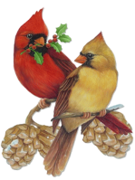  Merry Christmas Cardinals | Merry Christmas New Year Truck | Joy of the Season | Jesus is the Reason | Happy Holidays Buffalo Plaid | Let it Snow Chalkboard
Bird | 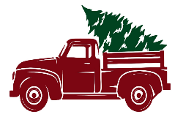  Tru | Joy | 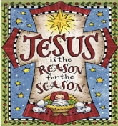  Jesu | Buff | Snow
Class of 2020 Christmas Fundraiser
Student: _________________________
Name and Phone Number
Sample Order |  |  | 2 |  |  |  |  | 1 |  |  |  |  |  |  | 3 | H | $85
 |  |  |  |  |  |  |  |  |  |  |  |  |  |  | Bird
1 |  |  |  |  |  |  |  |  |  |  |  |  |  |  |  |  | $
2 |  |  |  |  |  |  |  |  |  |  |  |  |  |  |  |  | $
3 |  |  |  |  |  |  |  |  |  |  |  |  |  |  |  |  | $
4 |  |  |  |  |  |  |  |  |  |  |  |  |  |  |  |  | $
5 |  |  |  |  |  |  |  |  |  |  |  |  |  |  |  |  | $
6 |  |  |  |  |  |  |  |  |  |  |  |  |  |  |  |  | $
7 |  |  |  |  |  |  |  |  |  |  |  |  |  |  |  |  | $
8 |  |  |  |  |  |  |  |  |  |  |  |  |  |  |  |  | $
9 |  |  |  |  |  |  |  |  |  |  |  |  |  |  |  |  | $
10 |  |  |  |  |  |  |  |  |  |  |  |  |  |  |  |  | $
11 |  |  |  |  |  |  |  |  |  |  |  |  |  |  |  |  | $
12 |  |  |  |  |  |  |  |  |  |  |  |  |  |  |  |  | $
13 |  |  |  |  |  |  |  |  |  |  |  |  |  |  |  |  | $
14 |  |  |  |  |  |  |  |  |  |  |  |  |  |  |  |  | $
15 |  |  |  |  |  |  |  |  |  |  |  |  |  |  |  |  | $

Table top wreath $18
Mantel / tabletop Garland $25
Window Sill Swag $18
Large Centerpiece $20
Small Centerpiece $18
Wooden Sign $5
Cross Wreath $20
Deluxe Swag $20
Corner Swag $12
Small Swag 2 for $16
Candy Cane $18
Basket Wreath $12
Deluxe Wreath $25
Traditional Wreath $20
Cash or cheque when ordering. Make cheques out to CNBA.
Each customer must choose a color scheme. If not, a random color will be chosen for you.

Color scheme
Total
Plain Wreath $15

